Power Point O365 Training
By Muthana Alalaki
May 28, 2018
Oxfam
https://www.oxfam.org/

Table of Contents
Intro to PowerPoint 3
What is PowerPoint? 3
Change views 3
Create presentations 7
Build presentations from templates 7
Create presentations from scratch 11
Add and delete slides 15
Select and apply slide layouts 17
Add and format text 18
Add text to slides 18
Format lists on slides 20
Format lists on slides 22
Check spelling in your presentation 25
Add math to slides 26
Import a Word outline into PowerPoint 28
Add hyperlinks to slides 31
Add SmartArt to a slide 32
Add WordArt to a slide 34
Design presentations 35
Apply themes to presentations 36
Create, merge, and group objects on a slide 37
Align and arrange objects on slides 39
Layer objects on slides 42
Change slide masters 42
Organize slides into sections 43
Add footers to slides 44
Add transitions between slides 45
Get design ideas for slides 46
Present slideshows 48
Use Slide Show and Presenter View 48
Add speaker notes​ 51
Practice and time your presentation​ 52
Print presentations​ 53
Record presentations 54
Add audio and video 56
Add, format, and record video 56
Add and record audio 59
Add and format images 61
Add images to slides 61
Add screenshots to slides 61
Format images on slides 62
Add animations to slides​ 65
Add animations to slides​ 65
Add Excel tables to slides 67
Share presentations 69
Save presentations as videos​ 69
Remove sensitive information ​from your presentation 71
Add and review comments​ in your presentation 73
References 75

Intro to PowerPoint

What is PowerPoint?
With PowerPoint on your PC, Mac, or mobile device, you can:
- Create presentations from scratch or a template.
- Add text, images, art, and videos.
- Select a professional design with PowerPoint Designer.
- Add transitions, animations, and cinematic motion.
- Save to OneDrive, to get to your presentations from your computer, tablet, or phone.
- Share your work and work with others, wherever they are.

Change views
Although the Normal view is probably the most common one used, there are other views that come in handy for different tasks and preferences.
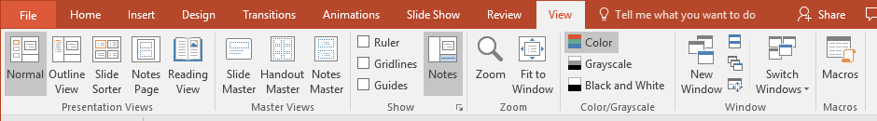
Display Normal view
This is the default view.
- Select View > Normal.
Or, select Normal from the task bar at the bottom of the window.
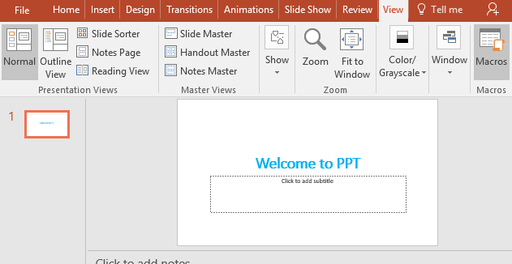
Display Outline View
Use this view to see a text outline or story board of your presentation.
- Select View > Outline View.
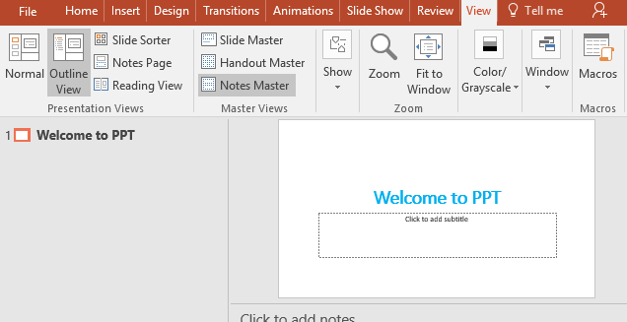
Display Slide Sorter view
Use this view to see the order of your slides, or to reorganize your slides.
- Select View > Slide Sorter.
Or, select Slide Sorter from the task bar at the bottom of the window.
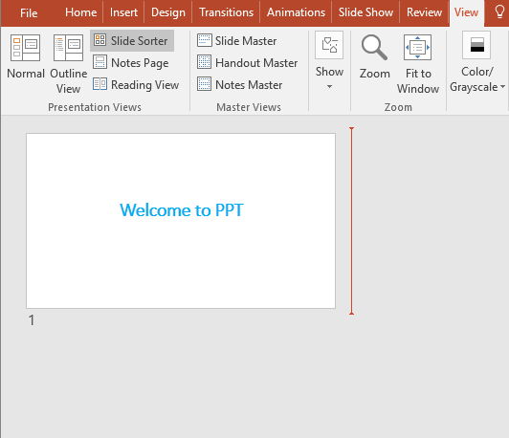
- To reorganize your slides, just click and drag your slides to a new location.
Display Notes Page view
Use this view to see how printed notes look, or as cues for yourself while you're presenting.
- Select View > Notes Page
Or, select Notes at the bottom of the slide window.
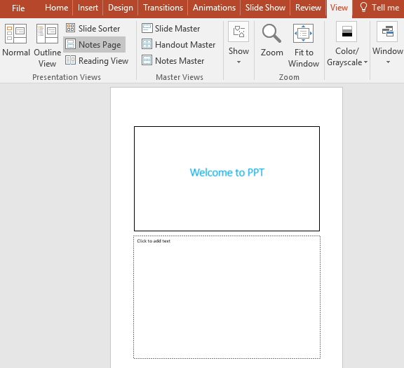
Display Reading View
Use this view to resize the window while viewing animations and transitions.
- Select View > Reading View.
- To close Reading View, press Esc or select another view in the task bar at the bottom of the window.
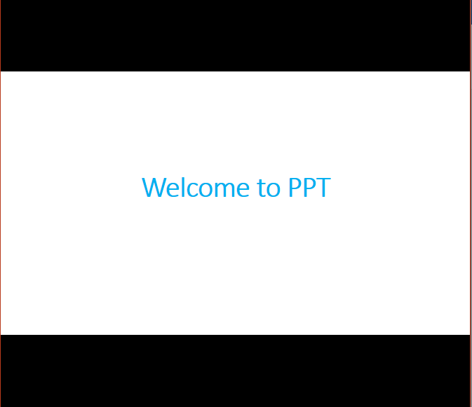
Display Master Views
To change the Slide Master:
- Select View > Slide Master.
Note: Be careful when making changes to the Slide Master, since changes to layouts in the Slide Master will be applied to all slides in your presentation that use that layout.
- To close a master view, select Close Master View.
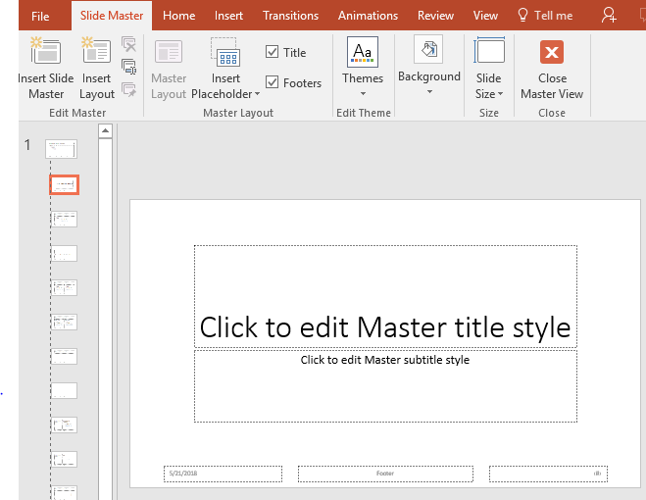
Change the color of the view
- Select the View tab.
Select Normal, Outline, or Slide Sorter view if you're not already in one of these views.
- Select Color, Grayscale, or Black and White to see how your presentation looks on the screen or printed.
Add a Ruler, Gridlines, or Guides
- Select the View tab.
- Select the options you want:
  - Ruler - to show horizontal and vertical rulers.
  - Gridlines - to show a grid.
  - Guides - to show automatic alignment guides.

